RNN Hyperparameter Tuning for Gesture Recognition
Steven Bontius | HAN Applied University | March 8th 2026

Introduction
This report documents an investigation into RNN architectures for gesture recognition using the SmartWatch gesture dataset. The primary goal was to achieve a 90% classification accuracy across 20 gestures.
The investigation revealed a methodological flaw in the standard data factory, leading to a data leakage investigation that forms the central contribution of this work. Correcting the flawed evaluation revealed that previously reported results where inflated and that the true challenge of generalising across users is considerable harder than the default setup suggests.

Data
The SmartWatch Gestures dataset contains accelerometer recordings from 8 users performing 20 distinct arm gestures, each repeated 20 times per user, yielding 3,200 sequences in total. Each sequence captures three-axis (x, y, z) acceleration at variable lengths, reflecting natural variation in gesture speed between users.
The raw recording lengths vary per user and required padding before padding. However, this creates an implicit user signature that can be detected in the data. The distinct gesture lengths are clearly visable in figure 1.This was the first sign of data leakage, and motivated the leakage analysis in Section 3.

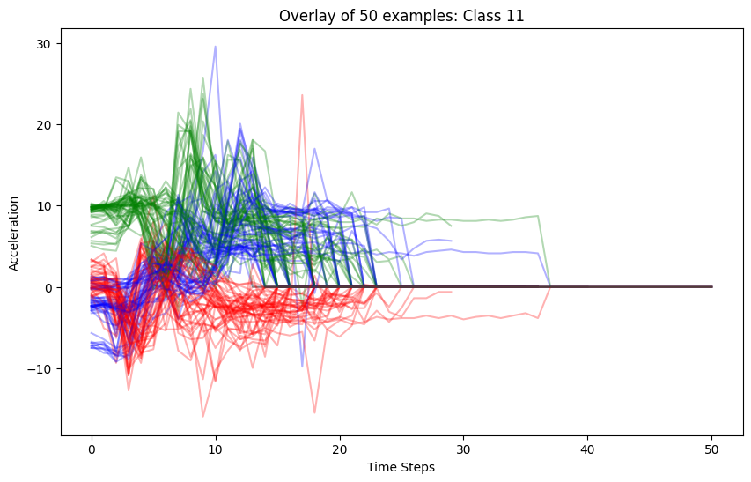
Figure 1. 50 examples for gesture 11

Data Leakage Analysis
The default DataFactory splits the data by randomly shuffling all 3,200 samples and taking an 80/20 split. This approach has a critical flaw: the same user and gestures appear in both the training and validation sets.
Consider user U01 who performed gesture 7 twenty times. After a random 80/20 split, approximately 16 of those recordings appear in training and 4 in validation. The model is then evaluated on near-duplicate recordings from users it has already seen. This is not a test of generalisation; it is a test of memorisation.
Furthermore, the model learns user-specific length signatures that allow it to identify users rather than gestures.To prevent leakage, the evaluation was changed to Leave-One-User-Out (LOSO) cross-validation, where the model is trained on all users except one and validated on the held-out user.

LOSO Evaluation
To prevent leakage, the evaluation was changed to Leave-One-User-Out (LOSO) cross-validation, where the model is trained on all users except one and validated on the held-out user. A single holdout is insufficient to draw conclusions about generalisation, since some users may be inherently easier to classify than others due to differences in movement style, recording consistency, or gesture execution speed. By rotating the holdout across all eight users and reporting results for each fold, a complete picture of how well the model generalises across the full population emerges.
Experiments show that results vary significantly per held-out user, warranting the use of this evaluation protocol. See figure 2.

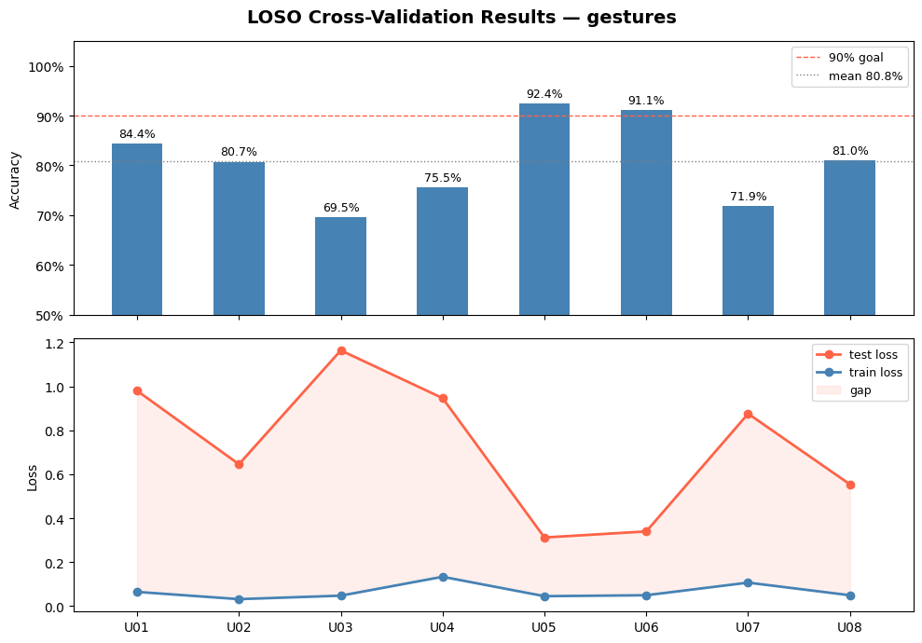
Figure 2. LOSO validation [held-out user on horizontal axis]

Experiments

All experiments were conducted under correct LOSO evaluation. Results are reported as mean accuracy across all eight holdout users. MLflow was used for experiment tracking throughout. An overview of the different models used can be found in the table below.
The largest improvement in accuracy came from increasing the number of layers in the model, from one to three. A possible explanation is that deeper architectures learn increasingly abstract representations of the gesture signal. The first layer captures low-level motion primitives such as individual acceleration peaks, the second layer combines these into partial gesture patterns, and the third layer learns full gesture sequences from those combinations. A shallower model is forced to learn all of this in a single step, resulting in representations that are more user-specific and less transferable to unseen users. Adding more layers did not significantly increase performance.
Finally, a 3-layer LSTM model was trained, achieving a mean LOSO accuracy of 90.8% and narrowly surpassing the 90% goal. This was the best performing architecture across all experiments, though the margin over the 4-layer GRU was small.
All models show signs of overfitting, reflected in a persistent gap between training loss and validation loss. Regularisation techniques including dropout, weight decay, and data augmentation with noise were applied systematically but failed to meaningfully improve performance.

Experiment | Mean Accuracy | Notes
Leaky GRU baseline | 99.7 % | Invalid
LOSO GRU baseline | 80.8 % | Honest starting point
LOSO GRU patient stopping | 84.4% | Good improvement
LOSO GRU patient increased decay | 81.7 % | No improvement
LOSO GRU patient augemented noise | 84.4 % | No improvement
LOSO GRU patient 3 layers | 89.1 % | Best improvement
LOSO GRU patient 4 layers | 90.5 % | Not much improvement
LOSO CONV1D + GRU 3 layers | 89.3 % | No improvement
LSTM 3 layer | 90.8 % | Best model, goal achieved
Tabel 1. Experiment overview

Overfitting
Throughout all experiments, a large gap persisted between training loss (near zero) and validation loss (0.2 to 1.4 depending on user). Standard regularisation techniques were applied systematically and failed to close this gap.
Classical overfitting occurs when a model memorises noise in training data due to excess capacity. The remedy is reduced capacity, dropout, and weight decay. This is not what is happening here.
The training loss approaches zero not because the model is memorising noise, but because it has genuinely learned every example it was shown: the movement patterns of 7 specific people. The validation user represents an 8th movement style the model has never encountered in any form.
No amount of regularisation can teach the model what it has never seen. Dropout, weight decay, and noise augmentation all failed to improve the mean because the bottleneck is data coverage, not model complexity.
What could fix this issue:
- Increase the amount of users would incrase the diversity of movement styles seen during training
- Stronger augmentation: simulate speed variation not just adding magnitude noise.

Results
The results of the best model are shown in figure 3.

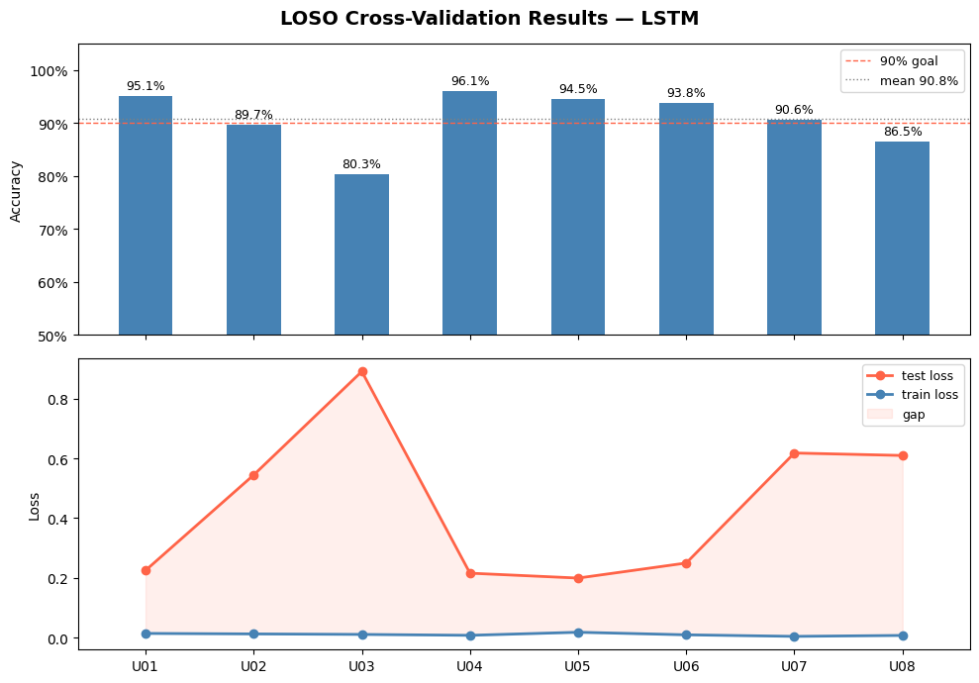
Figure 3. Final and best model (3-layer LSTM)

Key observations:
- 5 of 8 users exceed the 90% goal individually; the mean of 90.8% is pulled down by U03 and U08
- The loss gap remains large for all users, confirming distribution mismatch rather than classical overfitting
- U03 is the most persistent outlier across all experiments, suggesting a movement style genuinely dissimilar to the other 7 users

Conclusion
This investigation achieved a mean LOSO accuracy of 90.8% using a 3-layer LSTM architecture, marginally exceeding the 90% goal under methodologically correct evaluation conditions.
The most important finding is not the final accuracy but the leakage discovery. The standard dataset factory produces a 99.69% result that is entirely invalid. Correcting the evaluation to LOSO revealed the true baseline of 80.8%, a gap of about 20 percentage points attributable to the model learning user identities rather than gesture patterns.
Architecture depth was the dominant factor in improving performance. Adding layers improved accuracy from 80.8% to 90.5% for GRU. Regularisation techniques including dropout, weight decay, and data augmentation produced negligible gains, consistently indicating that the performance ceiling is set by the diversity of the training population rather than by model capacity.

Reflection

What worked:
- Identifying and correcting the data leakage before investing in architecture search
- Systematic per-user reporting via the LOSO plot function, which made the inter-user variance immediately visible
- Using MLflow consistently, enabling direct comparison across all experiments

What to do differently:
- Start with TPE hyperparameter search: manual one-variable-at-a-time experimentation consumed significant time.
- Report best epoch metrics rather than last epoch: early stopping does not guarantee the final epoch is the best
- Check best practices on the use of ML-flow

Limitations:
- 8 users is a very small population sample; results may not generalise to a broader demographic
- Metrics are last-epoch values from MLflow, not best-epoch values
- No confusion matrix analysis was performed; it is unknown which specific gestures are confused for hard users
- A single random seed was used; results may vary across initialisations

